**Jonathan Houston**

**omu075/01389484**

**Homework Assignment #1 B-Tree Manipulation.**

**(10 points, due Th Feb 1st, begin of class)**

**Given:**

- A B-Tree of order 2.

- Initially the root level has one node with the following

- Keys:

20 40 60

- Leaf nodes with the following keys:

5 10 15

22 25 30 35

45 50 55

65 70 75 80

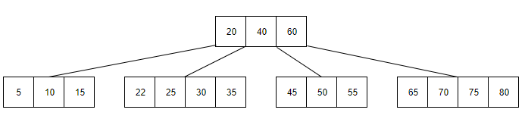

**1. For each of the following insertions, show the B-Tree:**

23

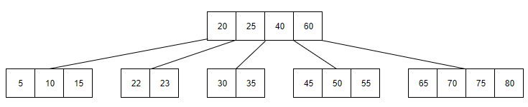

**2. Continuing from #1, show the B-Tree resulting after both of these insertions: (It isn't necessary to show it after its first insertion.)**

44, 57

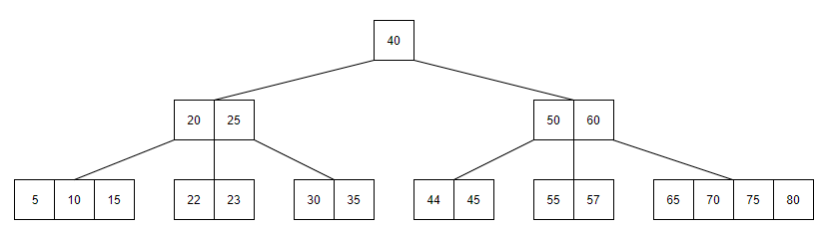

**3. For each of the following deletions from the B-Tree in #2, show the B-Tree:**

60

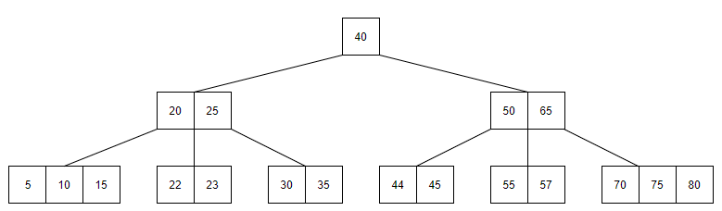

**4. For each of the following deletions from the B-Tree in #3, show the B-Tree:**

40

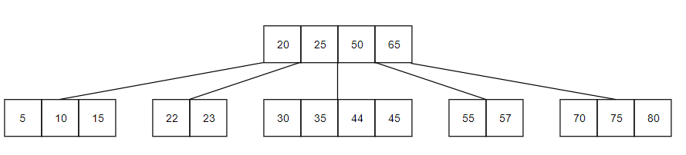

**5. For each of the following deletions from the B-Tree in #4, show the B-Tree:**

35

